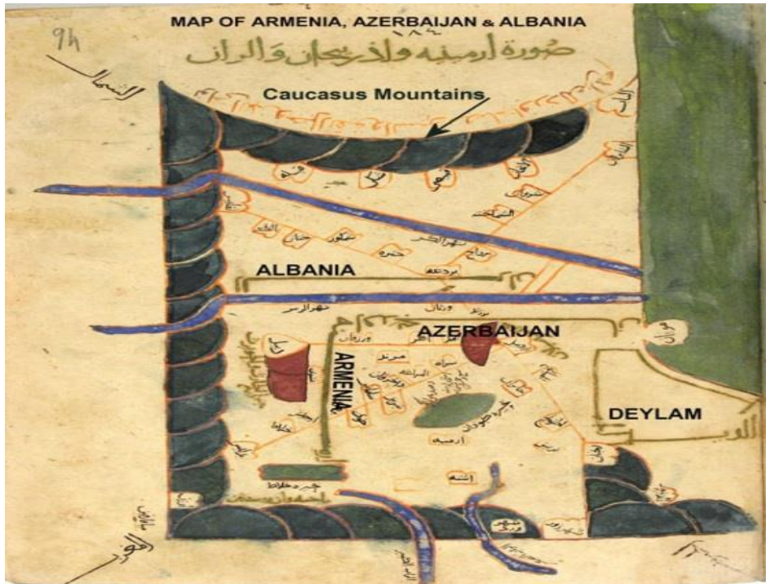
Figure 1: Ibn Hawqal's map of Armenia, Azerbaijan and Arran.

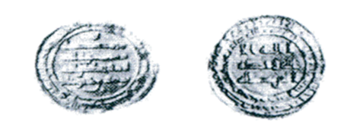
Figure 2- An example of a dinar coin minted by
Yusuf ibn Abi al- in 303 AH in Armenia (Dabil)

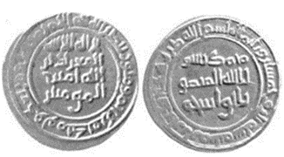

Figure 3: Coin minted in Armenia in 353 AH

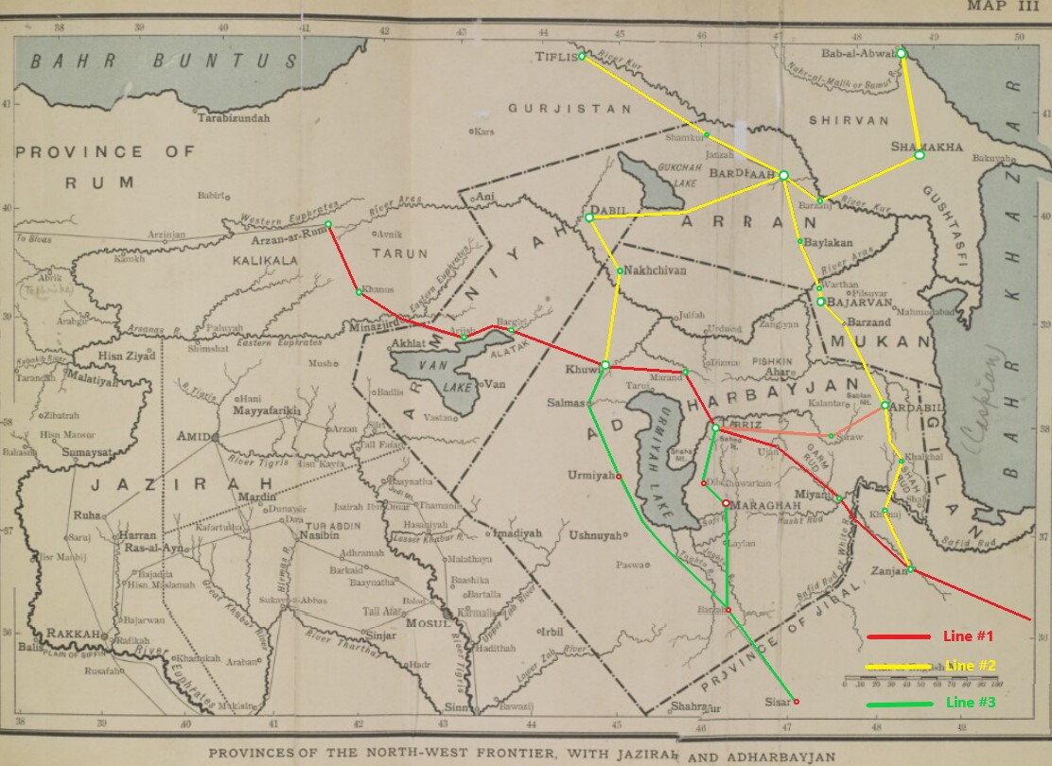
Figure 4: Map of the Province of Jazirah and Azarbaijan, Arran and Armenia and northwest frontier.

